**Average Education and Growth in Earnings by State**

* Following are the top 10 states according to the number of people employed and average earnings (millions) per job in 2019:

|  |  |
| --- | --- |
| **Top 10 states – 2019**  **(No. of educated people)** | |
| **State** | **2019** |
| California | 4,330,535 |
| Texas | 2,717,435 |
| New York | 2,418,300 |
| Florida | 1,745,405 |
| Illinois | 1,441,205 |
| Pennsylvania | 1,273,570 |
| New Jersey | 1,101,485 |
| Ohio | 1,015,845 |
| Georgia | 1,005,425 |
| Virginia | 1,001,990 |

|  |  |
| --- | --- |
| **Top 10 states - 2019**  **(Average earnings per job)** | |
| **State** | **2019** |
| New York | $92061 |
| Massachusetts | $89258 |
| California | $87226 |
| Connecticut | $83968 |
| Washington | $83904 |
| New Jersey | $82047 |
| Alaska | $81213 |
| Maryland | $80157 |
| Illinois | $77248 |
| Virginia | $75465 |

* Following are the Standard deviations of Educational attainment and Average earnings (millions) per job from 2009 to 2019 across the states:

|  |  |  |
| --- | --- | --- |
| **Year** | **Std. Dev (Educated People)** | **Std. Dev (Average earnings)** |
| 2009 | 600563 | 7415.67 |
| 2010 | 599535 | 7709.31 |
| 2011 | 611611 | 7931.54 |
| 2012 | 628913 | 7913.84 |
| 2013 | 644278 | 7965.55 |
| 2014 | 668572 | 8223.85 |
| 2015 | 691391 | 8535.72 |
| 2016 | 711853 | 8544.52 |
| 2017 | 739189 | 8799.15 |
| 2018 | 759795 | 9108.92 |
| 2019 | 784118 | 9480.75 |

* The standard deviations of educational attainment by individuals and the average earnings per job are increasing over the years, which suggests that the States are growing apart in terms of both the variables (average earnings and educational attainment) over the years.
* Following table represents Ohio’s rank according to different variables:

|  |  |
| --- | --- |
| **Ohio’s Ranking** | |
| Average earnings per job in 2019 | 28th |
| Percent change in average earnings per job between 2009 and 2019 | 31st |
| Number of people educated in 2019 | 43rd |

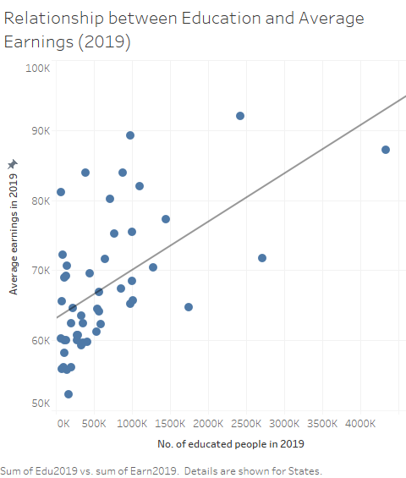

* Looking at the graph, it is quite evident that educational attainment by people and Average earnings per job have a positive correlation, i.e., as more people got educated in 2019, their average earnings per job increased.